**Computer Network Design in CISCO Packet Tracer**

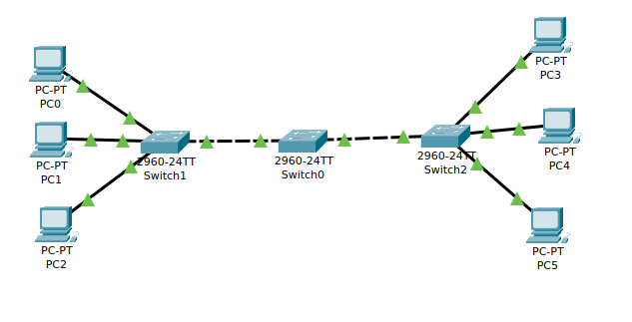**Implementing Switch in Computer Network**

**Implementing Server and Fetching IP Address from DHCP in Computer Network**

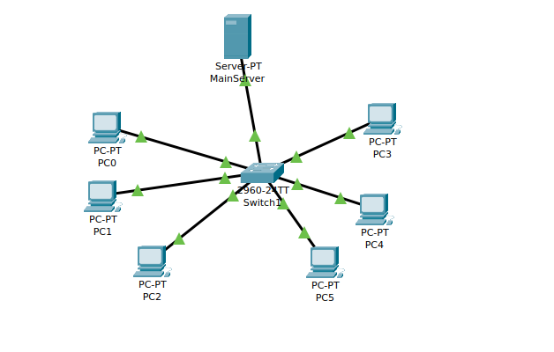

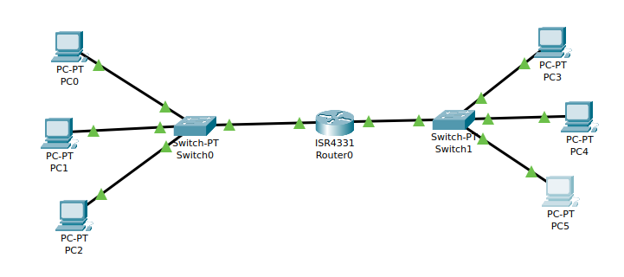**Implementing Router in two different Computer Network**